# PDF TOOLS SUITE

Semester VI

Academic Year 2024-25

A Project Submitted to

## University of Mumbai for Partial Completion of the Degree of

Bachelor of Science (Computer Science)

Under the Faculty of Science

By

# SHRAVANI GAJANAN SAWANT

**Roll No. :-243104**

**Under the Guidance of**

**Asst. Prof. Sampurna Mishra**



**Saket College of Arts, Science and Commerce, Kalyan East**

**UNIVERSITY OF MUMBAI**



SAKET GYANPEETH’S

**SAKET COLLEGE OF ARTS, SCIENCE & COMMERCE**

**(Affiliated to University of Mumbai)**

**NAAC Accredired B Grade**

|  |
| --- |
| **Department of Computer Science** |

**CERTIFICATE**

***This is to certify that***

**Shravani G. Sawant**

Has Completed the Project Work Entitled

## PDF Tools Suite

Submitted the same in the Partial Fulfillment of Bachelor of Computer Science

**Degree** of Mumbai University.

***Project Guide Head of the Department***

***Principal Internal Examiner External Examiner***

## Declaration

### I, Shravani Gajanan Sawant hereby declare that the project entitled “PDF

**Tools Suite”** done at **“Saket College of Arts, Science & Commerce”** submitted in the partial fulfilment for the award of **BACHELOR OF SCIENCE IN COMPUTER** SCIENCE during the academic year 2025-26 is our original work and the project has not formed the basic for the award of any degree, associateship, fellowship or any other similar titles**.**

### Signature of Students,

**Place:**

**Date:**

## Abstract

The **PDF Tools Suite** is a comprehensive, web-based platform designed to simplify the manipulation and editing of PDF documents. Built with modern web technologies such as HTML, CSS, and JavaScript, this suite offers a wide range of powerful tools that address common PDF-related tasks.

These include **PDF compression**, which reduces file size without compromising quality; **JPG to PDF,PDF to Word** and **Word to PDF** converters, enabling seamless format transformation; **PDF splitting and merging**, allowing users to extract and combine pages or entire documents; **adding page numbers** for enhanced document organization; **password protection** for securing sensitive content; and **OCR (Optical Character Recognition)**, which extracts text from scanned or image-based PDFs for easier editing and searching. Accessible directly through a web browser, the PDF Tools Suite provides an intuitive, no-installation-required solution for users, from casual users to professionals, needing to manage their PDFs quickly and efficientl.

By combining ease of use with powerful functionality, the platform makes it easier than ever to handle a variety of PDF tasks in a single, user-friendly interface. Whether you're reducing file sizes for email sharing, converting documents for compatibility, or protecting sensitive files, the PDF Tools Suite is a versatile toolset that meets the needs of today's digital document workflows.

### Acknowledgement

I am using this opportunity to express my gratitude to everyone who supported me throughout the course of this project. I am thankful for their aspiring guidance and friendly advice during the project work. I am sincerely grateful to them for sharing their truthful and illuminating views on a number of issues related to the project. There are many who helped me with this project and I want to thank them all from the core of my heart.

I express my warm thanks to my respected head of the division **Asst. Prof. Sampurna Mishra**, for allowing me to use the facilities available and also help me to coordinate my project

Furthermore, I would also like to acknowledge with much appreciation the crucial role of faculty members on this occasion.

Last but not least, I would like to thank friends who help me to assemble the parts and gave a suggestion about the project.

With sincere Thanks,

Shravani G. Sawant

### Approval For Project Proposal

PRN NO. :- 2022016401788361

Roll No. :- 243104

1. Name of the Students: - Shravani Gajanan Sawant
2. Title of the Project: - PDF Tools Suite
3. Name of the Guide: - Asst. Prof. Sampurna Mishra
4. Teaching experience of the Guide: -
5. Is this your first submission? Yes  No 

Signature of the Student: Signature of the Guide:

Date: Date:

Signature of the Coordinator:

Date:

### Plagiarism Report

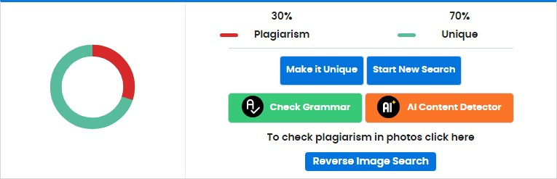

**INDEX**

|  |  |  |
| --- | --- | --- |
| **Sr.No.** | **Content** | **Page No.** |
| 1 | Introduction | 1-2 |
| 2 | Feasibility study | 3-4 |
| 3 | Scope of Project | 5-6 |
| 4 | Software & Hardware Requirements | 7 |
| 5 | System Design | 8 |
| 6 | UML | 9-16 |
| 7 | Database Design | 17-18 |
| 8 | System Testing | 19-20 |
| 9 | Output Of the Screen | 21-27 |
| 10 | Conclusion | 28 |
| 11 | Bibliography | 29 |
| 12 | Appendices | 30 |

**LIST OF FIGURES**

|  |  |  |
| --- | --- | --- |
| **Sr. No.** | **UML Diagrams** | **Page no.** |
| 1 | Use Case Diagram Admin | 19 |
| 2 | Use Case Diagram User | 20 |
| 3 | Entity-Relationship Diagram | 21-24 |
| 4 | 0 level DFD | 25 |
| 5 | 1 level DFD | 26 |
| 6 | 2 level DFD | 27 |
| 7 | Class Diagram | 28 |

### Introduction

Our class service is committed to providing students with the academic support and guidance they need to achieve their full potential. We understand that every student is unique, with different learning styles, strengths, and challenges. That's why we offer personalized, one-on-one tutoring sessions tailored to meet the specific needs of each individual. Whether a student needs help understanding a challenging concept, preparing for an upcoming exam, or simply looking to improve their overall academic performance, our experienced tutors are here to guide them every step of the way.

We offer tutoring across a wide range of subjects and academic levels, from foundational skills to advanced coursework. Our tutors not only focus on enhancing subject knowledge but also on fostering essential skills like critical thinking, problemsolving, and time management. With a patient and encouraging approach, we strive to create a positive and supportive learning environment that motivates students to engage actively in their education.

Our goal is not just to improve grades but also to boost students' confidence and in still a lifelong love for learning. By making complex topics more accessible and breaking them down into manageable steps, we help students gain a deeper understanding of the material, ultimately preparing them for success both inside and outside the classroom. We are passionate about helping each student unlock their full academic potential, and we take pride in being a part of their educational journey.

**Advantages:**

 

* **Personalized Learning**: Tailored lessons to individual needs.
* **Improved Performance:** Boosts grades and understanding.
* **Flexible Scheduling:** Easy to fit into busy routines.
* **Increased Confidence:** Builds student self-assurance.
* **Focused Exam Prep:** Effective for exam readiness.
* **One-on-One Attention:** Direct, undivided focus on the student.
* **Clearer Concepts:** Simplifies difficult topics.
* **Motivation:** Keeps students on track and engaged.  

 

 

**Disadvantages:**

 

* **Costly:** Tuition can be expensive.
* **Dependency:** Risk of relying too much on tutors.
* **Mismatch of Learning Styles:** Not all tutors fit every student's needs.
* **Limited Social Interaction:** Misses peer-based learning.
* **Pressure:** Extra stress may be placed on students.
* **Variable Quality:** Not all tutors are equally effective.
* **Time Commitment:** Requires consistent time and effort.

 

 

 

**Project Gantt**

**chart**

**:**

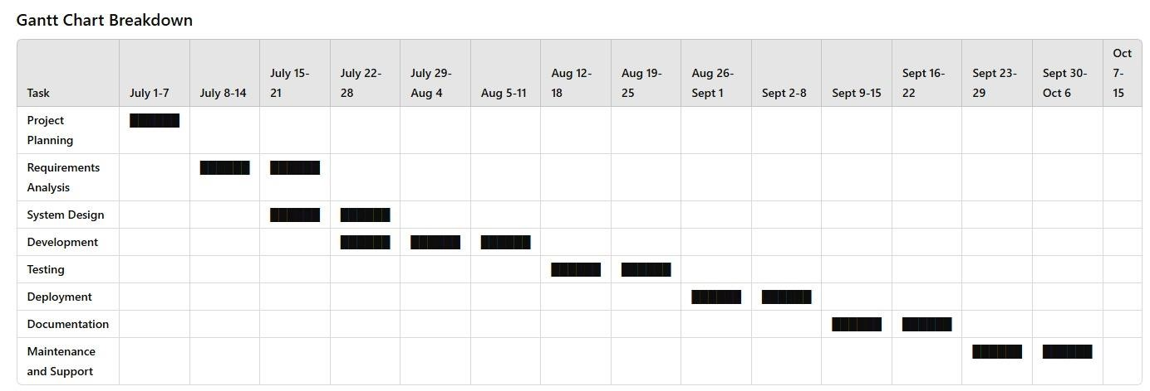

### Feasibility study

A **feasibility study** is a critical evaluation of the proposed project to determine whether it is viable. It examines the potential for success in terms of financial, operational, technical, and market aspects. Here's a breakdown of the **feasibility study** for the **Class Service Project**:

* + - Market feasibility
    - Technical feasibility
    - Financial feasibility
    - Legal feasibility
    - Operational feasibility
    - Social and Environmental feasibility

* **Market feasibility:** 
  + Demand: Analyze if there’s a high need for tutoring services in your target area.
  + Target Audience: Students, parents, or adults needing additional learning support.
  + Competition: Research local and online competitors; identify gaps.
  + Pricing: Offer competitive pricing based on market rates.
* **Technical feasibility:**

* Platform: Evaluate if you can develop an online platform for bookings and tutoring sessions.
* Tools: Consider tools for online sessions (Zoom, Google Classroom).
* Resources: Ensure access to quality tutoring materials and infrastructure (website, internet).

* **Financial Feasibility:**

* Initial Investment: Assess startup costs (website, marketing, tutor fees).
* Revenue Model: Determine pricing (per session, subscription) and project earnings.
* Costs: Account for ongoing expenses (staff, platform maintenance).
* Profitability: Estimate revenue to ensure the project is financially viable.

* **Legal Feasibility:**

* Licensing: Check for local regulations or licenses needed for offering tutoring services.
* Business Structure: Decide on legal structure (LLC, sole proprietorship).
* Taxes: Ensure tax compliance and business reporting.

* **Operational Feasibility:**

* Staffing: Ensure you can recruit qualified tutors.
* Scheduling: Develop a plan for booking and managing sessions.
* Customer Service: Create systems for handling inquiries and feedback.

* **Social and Environmental Feasibility:**

* Impact: Assess how the service will help students succeed academically.
* Social Responsibility: Can you offer support to underserved communities (discounts, free sessions)?
* Environment: Consider eco-friendly practices if using online tools.

### Scope of the Project

The **scope of a project** refers to the detailed description of what the project will accomplish, what deliverables will be produced, and the boundaries within which the project will operate.

It outlines the specific objectives, tasks, and outcomes of the project, providing a clear understanding of the project’s goals and expectations for all stakeholders involved.

It also defines the limitations, constraints, and exclusions to ensure that the project remains focused and manageable.

* **Objective:** 
  + Provide personalized tutoring in subjects like Math, Science, or English for middle and high school students.

* **Services Offered:** 
  + One-on-one sessions and small group classes.
  + In-person tutoring at a local center or school.
  + Homework help and test preparation.

* **Target Audience:** 
  + Students in grades 6–12 struggling with specific subjects.
  + Parents seeking additional academic support for their children.

* **Deliverables:** 
  + Tutoring sessions: Weekly or bi-weekly.
  + Progress tracking: Regular reports to show student improvement.
  + Additional resources: Study guides, practice tests, and learning materials.

* **Timeline:** 
  + Initial setup: Establishing classes and enrolling students within a month.
  + Regular sessions: Starting tutoring sessions from the next month.
  + Periodic reviews: Monthly progress check-ins for students and parents.

* **Budget and Resources:** 
  + Tutors: Hiring qualified teachers for each subject.
  + Classroom space: Renting or using a school facility.
  + Learning materials: Textbooks, worksheets, and online resources.

* **Exclusions:** 
  + No online platform development or virtual tutoring at this stage.
  + Not covering subjects outside core subjects like Math, Science, and English.

|  |  |  |
| --- | --- | --- |
| Space Academy : Elevate your Learning | 8 | 243112 & 243093 |

### Software & Hardware requirements

Here are the software requirements and hardware requirements for the project.

* **Software Requirements :**

* + - Database: MySQL
    - Server: Apache
    - Frontend: HTML, CSS
    - Scripting Language: JavaScript
    - IDE: Sublime Text, Visual Studio Code
    - Backend Technology: PHP
    - Framework (optional): Laravel (for PHP)
    - Version Control: Git

* **Hardware Requirements :**

* + Processor: Any processor after Pentium 4 or equivalent (e.g., Intel Core i3, i5)
  + Operating System: Windows 10 or later, or Linux-based systems (Ubuntu, CentOS)
  + Processor Speed: 2.0 GHz or higher
  + RAM: 4GB or more
  + Hard Disk: 80GB to 256GB SSD or HDD

### System Design

The system design for the tuition service project includes the following key components:

* **Frontend (Client Side):**

* + User interface for students and tutors (login, course listings, scheduling, chat). • Technologies: HTML, CSS, JavaScript (React or Angular).

* **Backend (Server Side):**

* + Web server handling requests and generating dynamic content.
  + Technologies: Apache (server), PHP (backend logic).
  + Database: Stores user info, courses, payments, schedules. • Technologies: MySQL.

* **Payment Gateway:**

* + For processing payments (e.g., PayPal, Stripe).

* **Real-Time Communication:**

* + Video conferencing for online sessions using WebRTC or integration with services like Zoom.
* **Security**:

* + SSL/TLS encryption, secure authentication, and data protection.

* **System Flow:**

* + Users (students/tutors) register and log in.
  + Students enroll in courses, and tutors manage them.
  + Sessions are scheduled and payments processed. • Real-time video communication for lessons.

This design ensures smooth operation of the platform with secure and efficient communication and course management.

### Unified Modelling Language Diagrams (UML)

For the tuition service project, several UML (Unified Modeling Language) diagrams can help represent different aspects of the system design. Below are the key UML diagrams that would be useful for this project:

* Use Case Diagram
* Class Diagram
* Sequence Diagram
* Activity Diagram
* Component Diagram

▪ **Use Case Diagram :**

Purpose: This diagram represents the high-level functionality of the system and the interactions between users (students, tutors, and admins) and the system.

Use Cases:

* Student: Register, Log in, Browse Courses, Enroll in Courses, Schedule Session, Make Payment, Chat with Tutor, Join Video Session.
* Tutor: Register, Log in, Create Courses, Manage Sessions, Chat with Student, Conduct Video Session.
* Admin: Manage Users (Students and Tutors), View Reports.

Example:

* **Class Diagram :**

Purpose: This diagram shows the structure of the system by representing classes, attributes, methods, and relationships between classes.

**Key Classes:**

* User :

ID, Name, Email, Password, Register(), Login() ▪ Student :

EnrolledCourses, Schedulre, Enroll(), ViewCourses(), PayFees() ▪ Tutor :

CoursesCreated, Schedule, CreateCourse(), ViewSessions(), ConductSession() ▪ Course :

Attributes: CourseID, CourseName, TutorID, StudentList,AddStudent(), AssignTutor()

* Session

#### SessionID, Date, Time, TutorID, StudentID, StartSession(), EndSession()

Example

▪ **Sequence Diagram :**

Purpose: This diagram shows how objects interact in a sequence of events for a particular use case (e.g., student enrolling in a course or scheduling a session).

Example Scenario: A student enrolling in a course.

Objects Involved: Student, Course, Database, Payment Gateway.

Steps:

* Student selects a course.
* System checks course availability (queries Database).
* Student makes payment (interacts with Payment Gateway).
* System updates enrollment in the Database.

Example

|  |  |  |
| --- | --- | --- |
| Space Academy : Elevate your Learning | 15 | 243112 & 243093 |

▪ **Activity Diagram :**

Purpose : An Activity Diagram visually represents the workflow of processes within the tuition service system. It helps in understanding the sequence of actions, decision points, and interactions between users (students, tutors, admins) and the system.

Steps:

* Start
* Student logs into the system.
* Student browses available courses.
* Student selects a course.
* System checks course availability (Database query).
* Student makes a payment (interacts with Payment Gateway).
* System updates student enrollment in the database.
* Confirmation message sent to the student.
* End

Example

▪ **Component Diagram :**

Purpose : Component Diagram represents the structural organization of the system, showing how different components interact with each other.

Steps :

* User Interface (UI) – Student UI, Tutor UI, Admin UI.
* Authentication Module – Manages login/registration.
* Course Management System – Handles course creation, browsing, and enrollment.
* Scheduling System – Manages session bookings.
* Payment Gateway – Processes payments and updates records.
* Chat & Video System – Enables real-time communication.
* Database – Stores users, courses, payments, and schedules.
* Admin Management System – Allows user management and reporting.

Example

### System Testing

System testing is a crucial phase in software development where the entire tuition service system is tested as a whole. It ensures that all modules—such as user registration, course management, session scheduling, payments, and communication—work together seamlessly.

This testing evaluates both functional and non-functional aspects of the system. Functional testing ensures that features like course enrollment, payment processing, and chat functions operate correctly. Non-functional testing assesses performance, security, usability, and scalability. Since the tuition service involves multiple actors (students, tutors, and admins), system testing verifies whether role-based access and permissions are correctly implemented..

* **Functional Testing Techniques :**

* + Black Box Testing – Verifies if students can enroll in courses, tutors can create sessions, and payments are processed without internal code checks.

* + Unit Testing – Tests individual components like user registration, course creation, and payment processing separately.

* + Integration Testing – Ensures smooth interactions between modules, such as payment confirmation updating enrollment status.

* + System Testing – Checks the complete system, ensuring all features work together.

* + User Acceptance Testing (UAT) – Ensures that students, tutors, and admins find the system easy to use and error-free.

* + Regression Testing – Confirms that system updates (like new payment

options) do not break existing features.

* **Non-Functional Testing Techniques :**

* + Performance Testing – Evaluates system speed while handling multiple student enrollments and tutor sessions.

* + Load Testing – Ensures the system can handle many users accessing courses simultaneously.

* + Security Testing – Protects against unauthorized access, payment fraud, and data breaches.

* + Usability Testing – Tests if students and tutors can easily navigate course selection, scheduling, and payments.

* + Compatibility Testing – Checks if the platform works on different devices (PC, mobile, tablets) and browsers.

It also checks how the system handles high user loads, ensuring a smooth experience even during peak times. Security is another critical aspect, as the system deals with sensitive user data and financial transactions.

Ultimately, system testing ensures that the tuition service platform is reliable, secure, and user-friendly, providing a seamless learning experience for students and tutors.

### Database Design

The database design of a project ensures efficient data management, seamless interactions between students and tutors, and secure transactions. It involves structuring data entities, relationships, and constraints to optimize performance and maintain data integrity.

A database is a collection of interrelated data stored with minimum redundancy to serve many users quickly and efficiently. The general objective is to make database access easy, quick, inexpensive and flexible for the user. Relationships are established between the data items and unnecessary data items are removed. Normalization is done to get an internal consistency of data and to have minimum redundancy and maximum stability. This ensures minimizing data storage required, minimizing chances of data inconsistencies and optimizing for updates. The MS Access database has been chosen for developing the relevant databases.

|  |  |  |
| --- | --- | --- |
| Space Academy : Elevate your Learning | 21 | 243112 & 243093 |

### Database Design

The data in the system has to be stored and retrieved from database. Designing the database is part of system design. Data elements and data structures to be stored have been identified at analysis stage. They are structured and put together to design the data storage and retrieval system.

A database is a collection of interrelated data stored with minimum redundancy to serve many users quickly and efficiently. The general objective is to make database access easy, quick, inexpensive and flexible for the user. Relationships are established between the data items and unnecessary data items are removed. Normalization is done to get an internal consistency of data and to have minimum redundancy and maximum stability. This ensures minimizing data storage required, minimizing chances of data inconsistencies and optimizing for updates. The MS Access database has been chosen for developing the relevant databases.

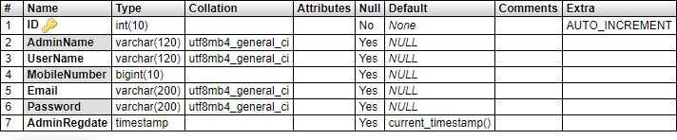

**“Online Security Guard Hiring System” (OSGHS) contains three MySQL tables :**

**tbladmin table Structure :** This table store the admin login and personal Details. **tblguard table Structure :** This table store ticket detail of security guard.

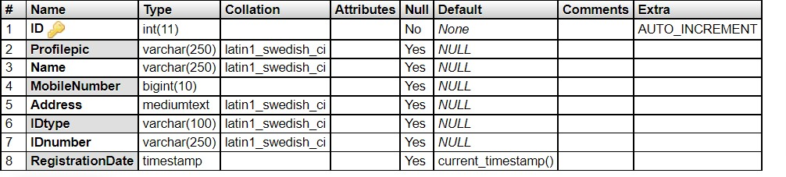

**tblhiring table Structure :** This table store security guard booking detail.

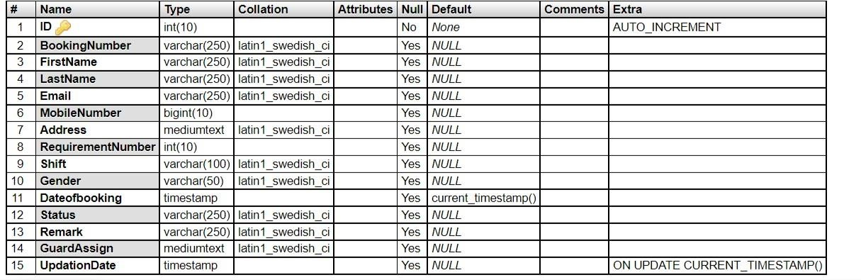

### Output Screen of Project

#### Hiring Form

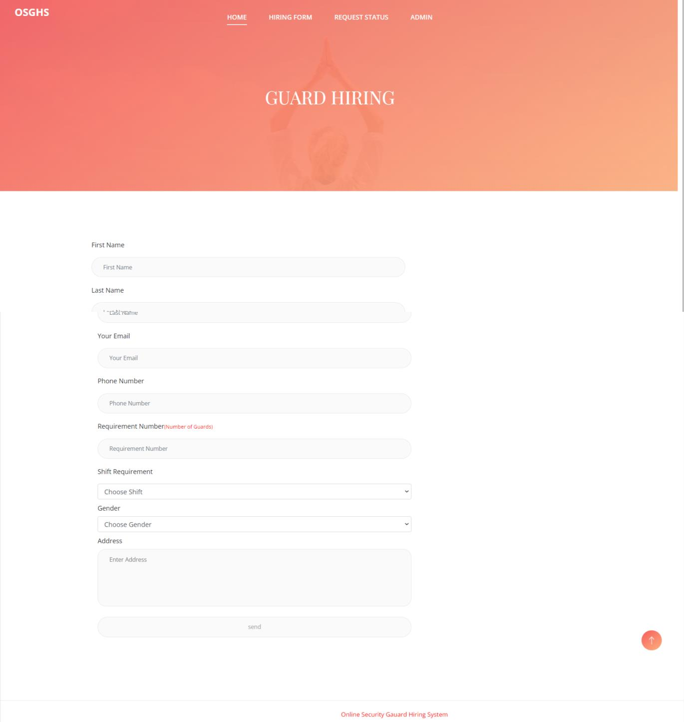

#### Search Hiring Request Status

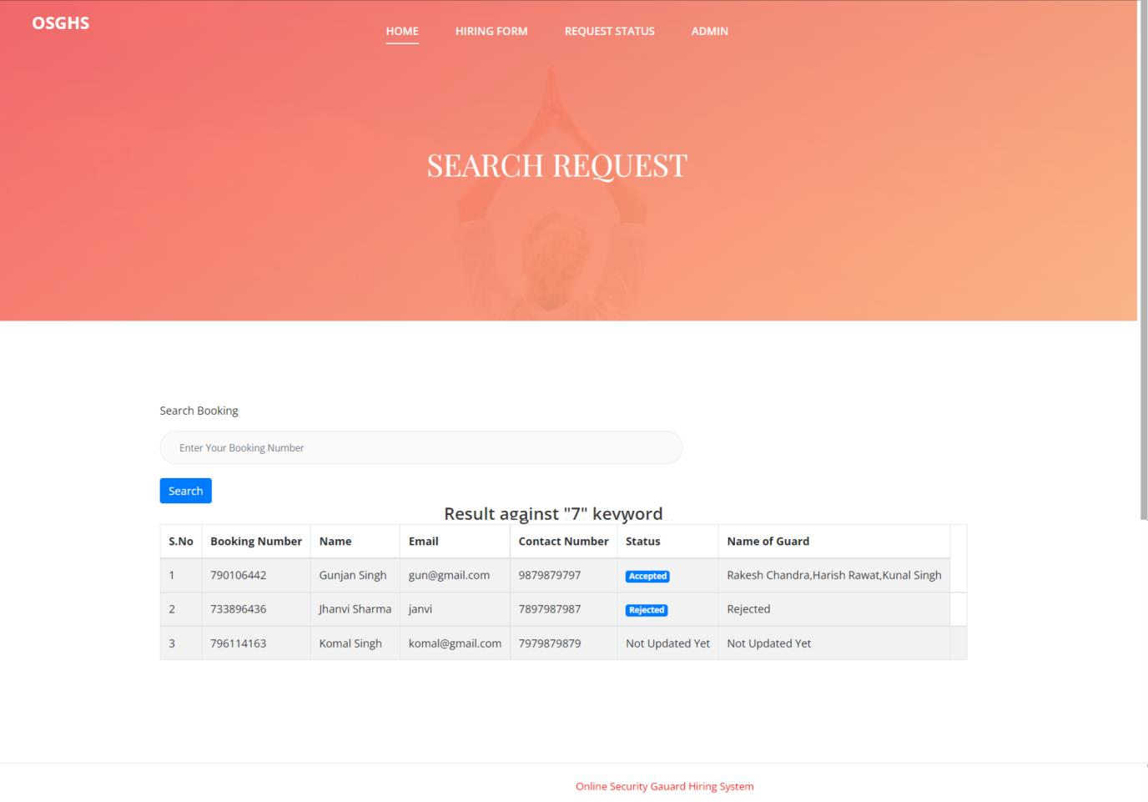

#### Admin Login

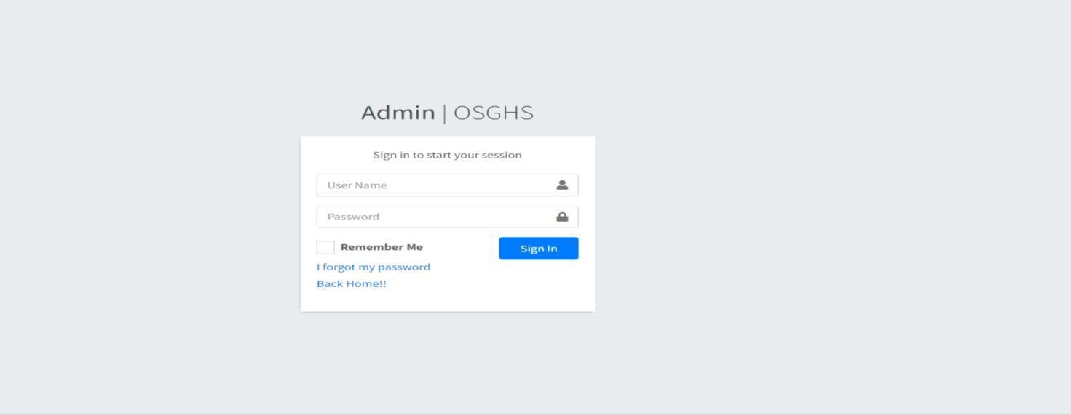

#### Add Security Guard

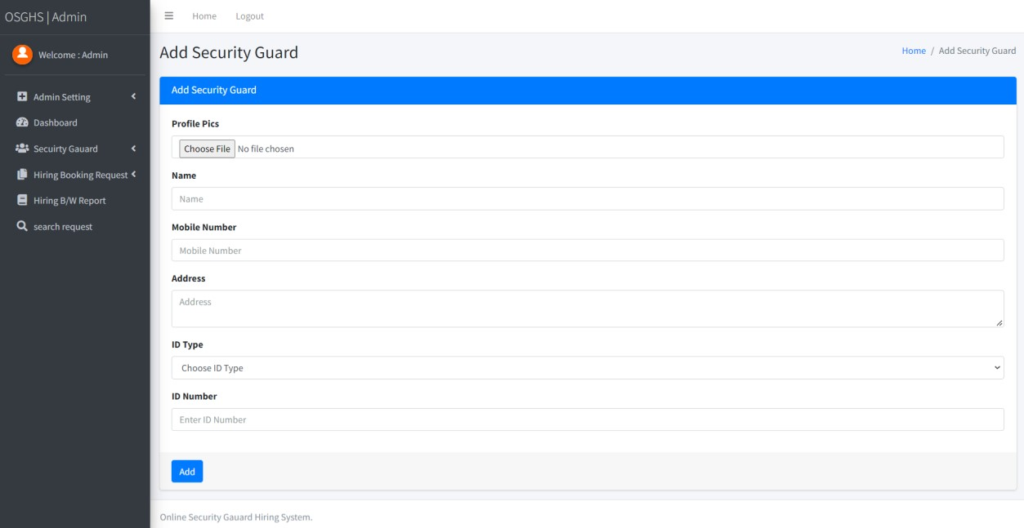

#### Manage Security Guard

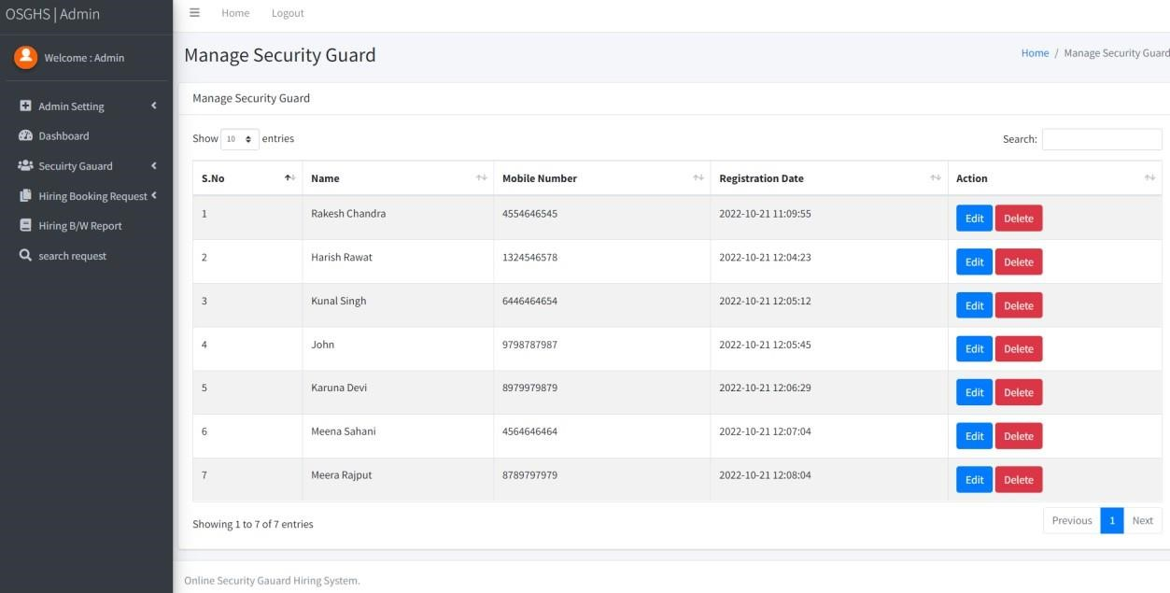

#### Dashboard

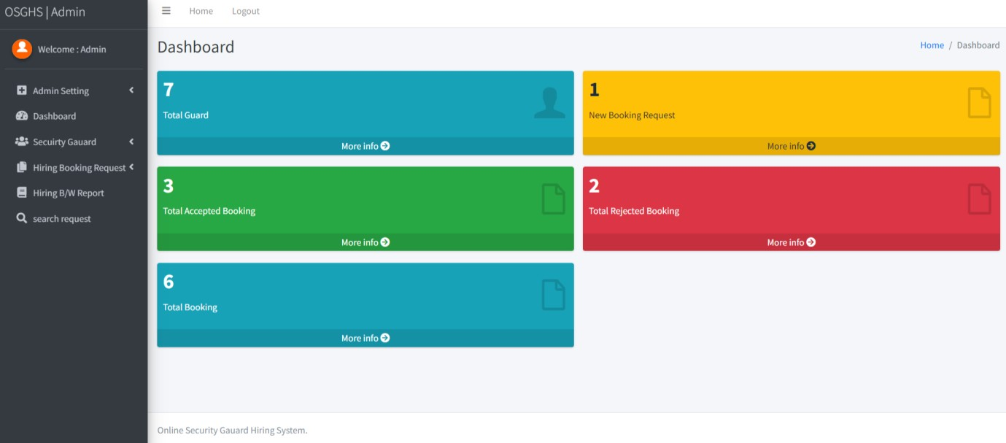

#### Admin Profile

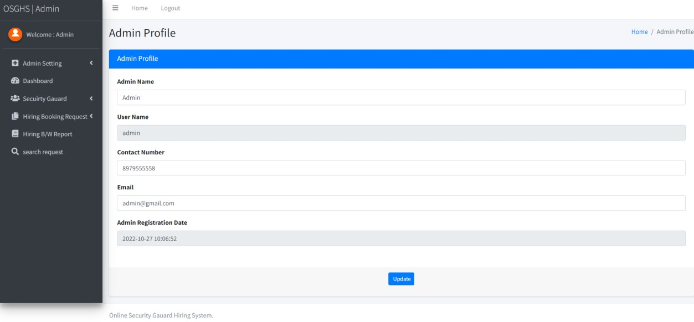

#### All Booking Request

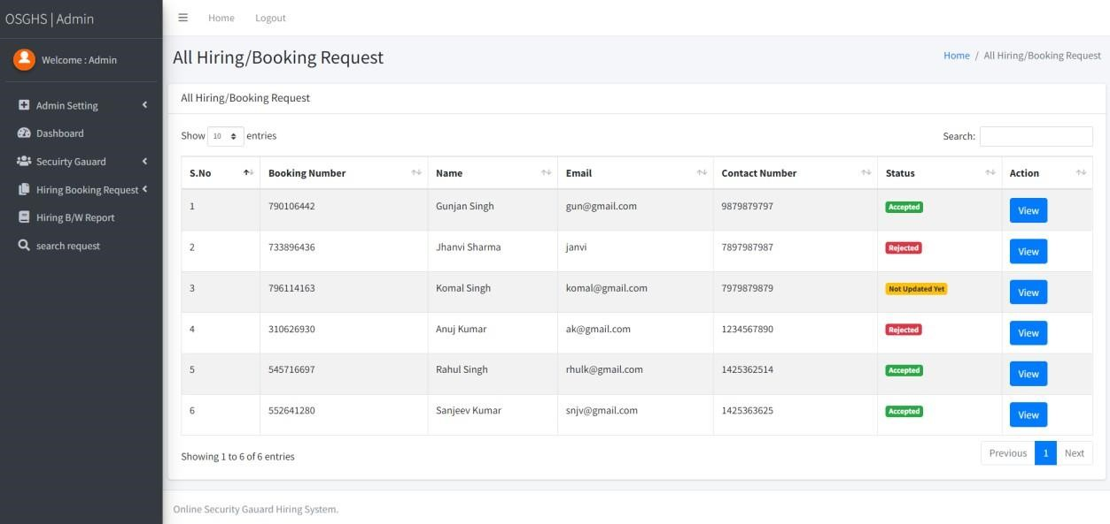

#### View All Booking Request

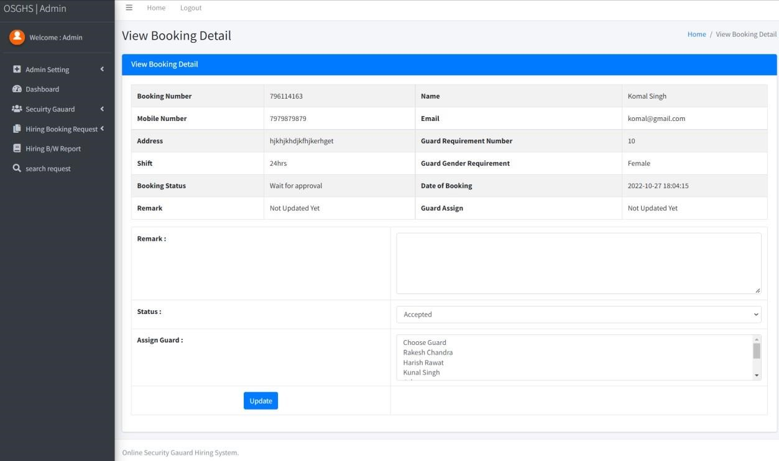

#### New Booking Request

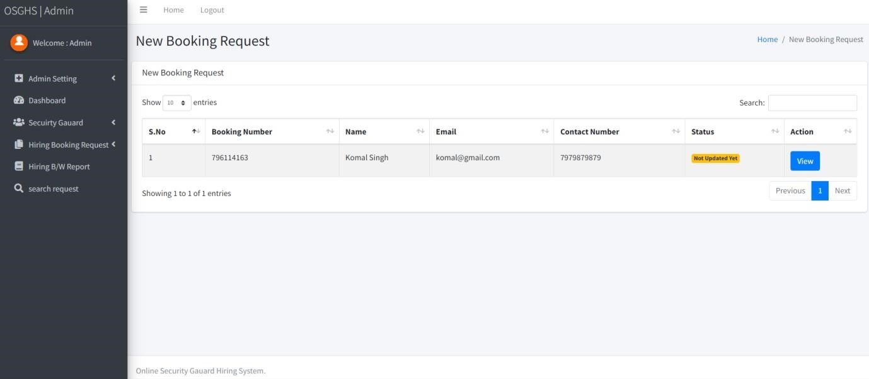

#### View New booking Request



#### Search Request

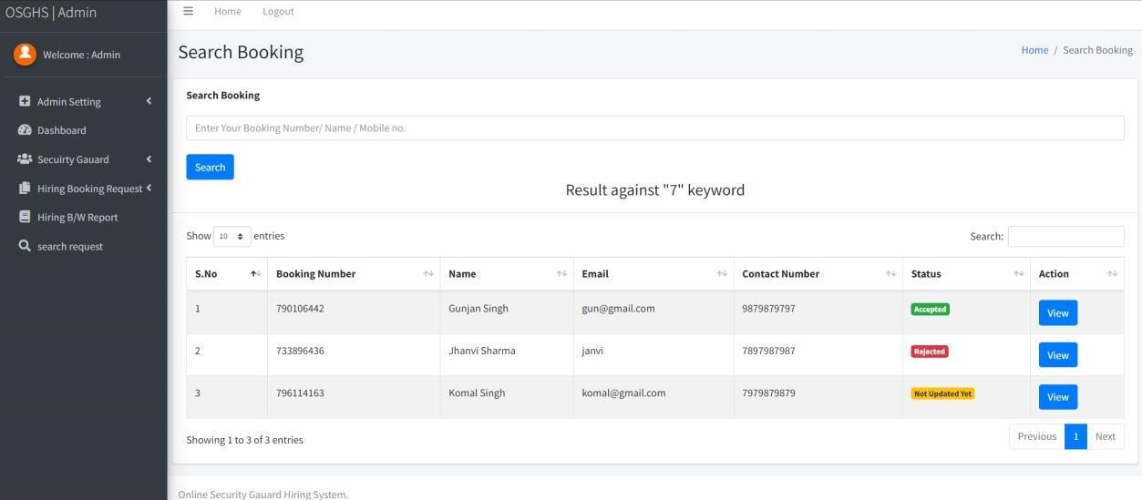

### Conclusion

The project titled as **“Space Academy : Elevate Your Learning”** was deeply studied and analyzed to design the code and implement. It was done under the guidance of the experienced project guide. All the current requirements and possibilities have been taken care during the project time.

**“Space Academy : Elevate Your Learning”** is a web based application aims to bridge the gap in education by providing personalized learning experiences tailored to students’ needs, this service enhances academic performance and confidence among students. The project also emphasizes accessibility, ensuring that students from diverse backgrounds can benefit from quality education.

With the integration of technology, continuous assessment, and adaptive learning techniques, the tuition service is positioned to make a lasting impact on students’ academic journeys. Moving forward, expansion and further innovation will be key to ensuring that more students can achieve their full potential.

|  |  |
| --- | --- |
| Space Academy : Elevate your Learning  **Bibliography**      **For PHP**   * <https://www.w3schools.com/php/default.asp> * <https://www.sitepoint.com/php/> * <https://www.php.net/>         **For MySQL**   * <https://www.mysql.com/> * [http://www.mysqltutorial.org](http://www.mysqltutorial.org/)     **For XAMPP**   * <https://www.apachefriends.org/download.html>       32 | 243112 & 243093 |

|  |
| --- |
| Space Academy : Elevate your Learning 243112 & 243093    **Appendices**    A. Database Schema   1. Job Hiring Table: • First name    * Last name    * Email    * Phone number    * Requirement Number    * Shift    * Address 2. Admin Table:    * Adminname    * Username    * Password    * ContactInfo    * Email 3. AddingSecurityTable    * ProfilePic    * Name    * Address    * Mobile number    * IDType    * IDNumber   B. User Guide:  Referred to the attached guide for detailed instructions on using the “Online security guard hiring system” hiring security guard, updating security member. C. Project Timeline:  See the attached timeline (Gantt chart) for the project schedule, task & milestones    33 |